**WorkTrack: Employee Timesheet Tracker**

**Database Project Documentation**

By

FRANZ LLOYD A. DIAZ

ARJONEL M. MENDOZA, MIT

Lecturer

# **PROJECT OVERVIEW**

# The Employee Timesheet Tracker is a system designed to record and manage employee work hours by tracking their clock-in and clock-out times. It aims to streamline attendance management, improve productivity monitoring, and ensure accurate payroll processing. This system was created by using Python, CustomTkinter, and MySQL.

# **ENTITY-RELATIONSHIP DIAGRAM (ERD)**

The ERD represents key entities in the Employee Timesheet Tracker such as employees and their attendance. Each entity has attributes essential for data management.

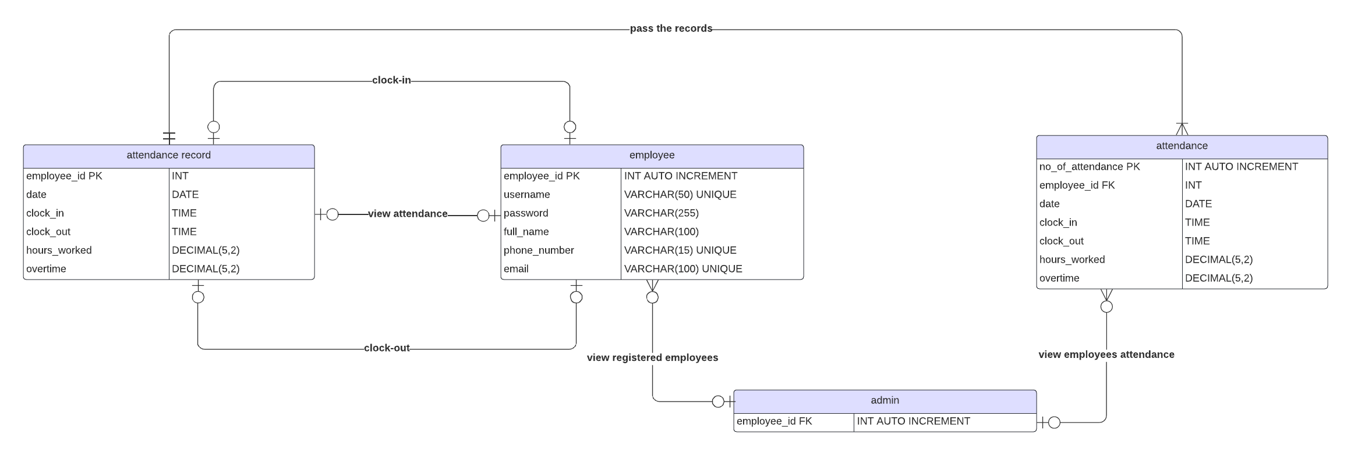

Figure 1. Entity Relationship Diagram

# **Entities and their Relationships**

1. **Books and Authors**

* **Type**: One-to-Many (1:N)
* **Description**: Each book is written by one author, but an author can write multiple books.

1. **Customers and Orders**

* **Type: One-to-Many (1:N)**
* **Description:** Each customer can place multiple orders, but each order is associated with only one customer.

1. **Suppliers and Books**

* **Type: Many-to-Many (M:N)**
* **Description:** Each supplier can supply multiple books, and each book can be supplied by multiple suppliers.

# **SQL SCRIPTS**

-- Create Database

CREATE DATABASE bookstore;

-- Use Database

USE bookstore;

-- Create Tables

CREATE TABLE Books (

book_id INT PRIMARY KEY,

title VARCHAR(100),

genre VARCHAR(50),

ISBN VARCHAR(13),

price DECIMAL(5, 2),

author_id INT,

FOREIGN KEY (author_id) REFERENCES Authors(author_id)

);

CREATE TABLE Authors (

author_id INT PRIMARY KEY,

name VARCHAR(100),

nationality VARCHAR(50)

);

CREATE TABLE Suppliers (

supplier_id INT PRIMARY KEY,

name VARCHAR(100),

contact_number VARCHAR(15)

);

CREATE TABLE Customers (

customer_id INT PRIMARY KEY,

name VARCHAR(100),

email VARCHAR(100),

phone VARCHAR(15)

);

CREATE TABLE Orders (

order_id INT PRIMARY KEY,

date DATE,

total_amount DECIMAL(8, 2),

customer_id INT,

FOREIGN KEY (customer_id) REFERENCES Customers(customer_id)

);

*.*